DATA SCIENCE CAPSTONE PROJECT REPORT

Product Performance Analysis and Predictive Modeling on Flipkart E-Commerce Data
Student Name: Hari haran G
Department: Data Science Aug-2025
Project Type: Capstone Project Report

ABSTRACT
This project presents an end-to-end data science framework for analyzing e-commerce product data collected from Flipkart.
The study includes data extraction through web scraping, data preprocessing, SQL database storage, exploratory data analysis,
machine learning modeling, and hyperparameter optimization. The objective is to derive actionable business insights and build
predictive models for product classification and performance analysis. The results demonstrate the effectiveness of machine
learning techniques in identifying pricing trends, customer engagement behavior, and product segmentation.

1. INTRODUCTION
E-commerce platforms generate massive volumes of product-related data such as pricing, ratings, and customer reviews.
However, this data is mostly unstructured and difficult to analyze manually. Data science methodologies provide tools
to transform raw web data into structured datasets and predictive insights. This project focuses on developing a scalable
pipeline for collecting, storing, analyzing, and predicting Flipkart product performance.

2. PROBLEM STATEMENT
The challenges addressed in this project include:
1. Product data is unstructured and scattered across multiple web pages.
2. Manual data analysis is inefficient and prone to human errors.
3. Lack of centralized relational database for structured analytics.
4. Absence of predictive models to analyze product performance and pricing trends.
5. Difficulty in identifying high-performing and low-performing products.

3. OBJECTIVES
1. Collect product data using Python web scraping techniques.
2. Clean and preprocess raw data for analysis.
3. Store structured data in a MySQL relational database.
4. Perform exploratory data analysis to identify patterns and trends.
5. Apply unsupervised learning for product segmentation.
6. Apply supervised learning models for prediction and classification.
7. Optimize models using hyperparameter tuning techniques.
8. Generate business insights for decision-making.

4. DATASET DESCRIPTION
The dataset was scraped from Flipkart and includes the following attributes:
- Product Name
- Price
- Category
- Rating
- Number of Reviews
The data was stored in CSV format and imported into a MySQL database for further analysis.

5. SYSTEM ARCHITECTURE DIAGRAM
Data Science Pipeline Architecture:
[ Flipkart Website ]
↓
[ Web Scraping using BeautifulSoup / Scrapy ]
↓
[ CSV Dataset Storage ]
↓
[ Data Cleaning & Preprocessing using Pandas ]
↓
[ MySQL Database Storage using SQLAlchemy ]
↓
[ Exploratory Data Analysis (EDA) ]
↓
[ Machine Learning Models ]
↓
[ Model Evaluation & Insights ]

6. WEB SCRAPING IMPLEMENTATION
Python code used for extracting product information from Flipkart:
import requests
from bs4 import BeautifulSoup
url = "https://www.flipkart.com/search?q=laptops"
response = requests.get(url)
soup = BeautifulSoup(response.text, 'html.parser')
products = soup.find_all('div', class_='_4rR01T')
for product in products:
print(product.text)

7. DATA CLEANING AND PREPROCESSING
Data preprocessing steps included removing duplicates, handling missing values, and converting data types.
import pandas as pd
df = pd.read_csv("flipkart_laptops.csv")
df.drop_duplicates(inplace=True)
df.fillna(0, inplace=True)
df['Price'] = df['Price'].str.replace('₹','').astype(float)

8. EXPLORATORY DATA ANALYSIS (EDA)
The following charts were generated for data analysis:
1. Price Distribution Histogram
2. Rating Distribution Bar Chart
3. Category-wise Product Count
import matplotlib.pyplot as plt
df['Price'].hist()
plt.title("Price Distribution")
plt.xlabel("Price")
plt.ylabel("Frequency")
plt.show()

9. UNSUPERVISED LEARNING (CLUSTERING)
K-Means clustering was applied to group products into budget, mid-range, and premium segments based on price, rating, and reviews.
from sklearn.cluster import KMeans
kmeans = KMeans(n_clusters=3)
df['Cluster'] = kmeans.fit_predict(df[['Price','Rating','Reviews']])

10. SUPERVISED LEARNING (CLASSIFICATION)
The following classification models were implemented:
- Logistic Regression
- Random Forest
- Support Vector Machine (SVM)
from sklearn.ensemble import RandomForestClassifier
model = RandomForestClassifier()
model.fit(X_train, y_train)

11. HYPERPARAMETER TUNING
Grid Search Cross Validation was used to optimize Random Forest model parameters.
from sklearn.model_selection import GridSearchCV
param_grid = {'n_estimators':[100,200],'max_depth':[10,20]}
grid = GridSearchCV(model, param_grid, cv=3)
grid.fit(X_train, y_train)

12. RESULTS AND DISCUSSION
The analysis showed that most products fall in low and mid-price categories. Premium products represent niche markets.
Machine learning models achieved high classification accuracy after hyperparameter tuning.

13. CONCLUSION
This project demonstrates a complete data science pipeline for e-commerce analytics. The methodology and results provide
actionable insights for pricing strategies, product classification, and business decision-making.

14. TOOLS AND TECHNOLOGIES
Python, Pandas, NumPy, Matplotlib, Scikit-learn, MySQL, SQLAlchemy, BeautifulSoup, Jupyter Notebook

15. REFERENCES
1. Flipkart E-Commerce Website
2. Scikit-learn Official Documentation
3. Python Official Documentation
4. Data Science and Machine Learning Textbooks

SYSTEM FLOWCHART DIAGRAM
The following flowchart represents the data science pipeline workflow.

RESULTS VISUALIZATION CHARTS
Figure 1: Price Distribution Chart
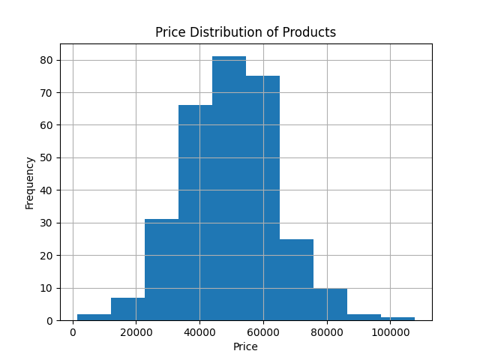
Figure 2: Rating Distribution Chart
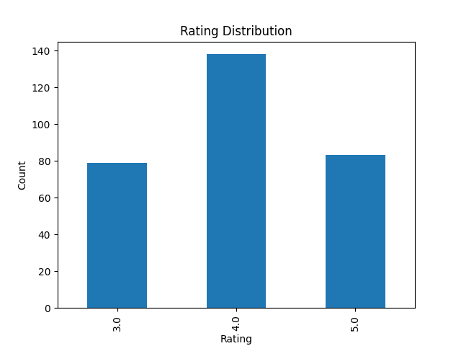
Figure 3: Product Clustering Scatter Plot
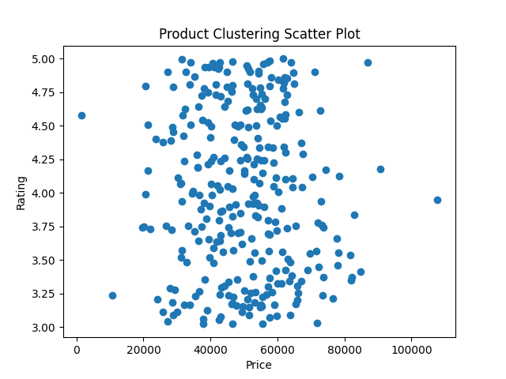
Figure 4: Confusion Matrix for Model Evaluation
